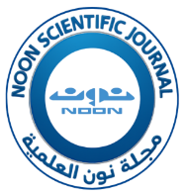
NOON Scientific Journal
مجلة نون العلمية

Dear Editor-in-Chief of NOON Scientific Journal (NOONSJ)

Greetings;

I affirm that my research titled (article title) is my original work and has not been submitted or published in any journal. It is not extracted from any book, thesis, or dissertation, and does not involve literary theft. I have not misappropriated the content without proper attribution, and I have not caused any harm or conflict with the interests of others. All authors are in agreement regarding the content of the research. I/ we (author/ authors name), have confirmed all the information in the article and account conclusively and have signed for it.

Sign:

Name:

Affiliation: for each author

Date:

Please note:
- No changes can be made to the article after the acceptance letter and publication of the research. The author (s) will be responsible for all the information provided in the research, and the journal is not responsible for the content of the article.
- No changes can be made to any information in the author's account, including name, title, and university address, after publication, except with special fees determined by the journal's management. The author (s) will be solely responsible for all details related to the research and information about co-author (s).
- Copyright ownership is transferred from the author (s) to the journal after the article is published, and the article cannot be deleted after publication in any way.

